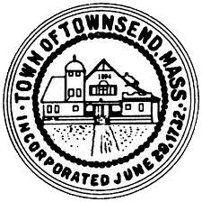
Townsend Historic District Commission
Meeting Agenda June 8, 2022 4:00 pm
Meeting room 2 Town Hall

- Call the meeting to order, conduct roll call.

- Approve meeting minutes of April 6, 2022, May 11, 2022
Votes may be taken

- Review an application for a Certificate of Appropriateness for exterior work to be done at 256 Main Street.
Votes may be taken.

- Review an application for a Certificate of Appropriateness for a new Town Hall sign at 272 Main Street.
Votes may be taken.

- Work Session

- Adjournment

